Oppgave 1d

import numpy as np

import matplotlib.pyplot as plt

fig = plt.figure(figsize =(10, 10))

ax = fig.add_subplot()

t = np.linspace(0, 2*np.pi, 200)

x = np.cos(t)

y = t*np.sin(t)

ax.plot(x,y, label="A parametric curve")

ax.legend()

plt.show()

ax = plt.figure(figsize =(10, 10))\

.add_subplot(projection="3d")

z = np.sin(5*t)*3*np.cos(t)

ax.plot(x, y, z, label=" A 3d parametric curve")

ax.legend()

plt.show()

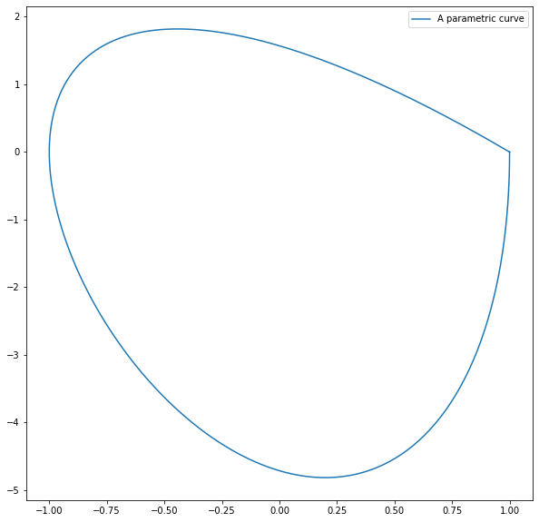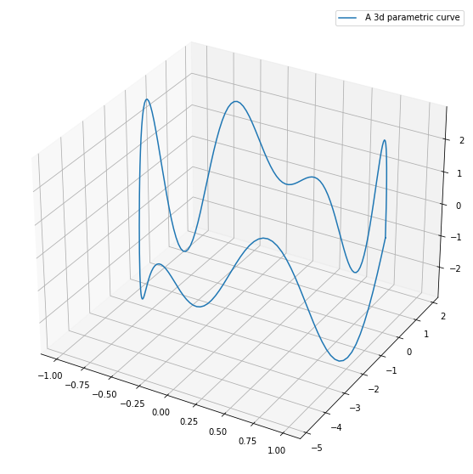

Oppgave 2b

import numpy as np

import matplotlib.pyplot as plt

fig = plt.figure(figsize =(10, 10))

ax = fig.add_subplot()

t = np.linspace(-1, 1, 100)

x = t

y = t**2 #Since (x,y) go goes thru the point (-1,1), (0,0) and (1,1)

#The formula for y will by y**2.

ax.plot(x, y, label="A parametric curve")

ax.legend()

plt.show()

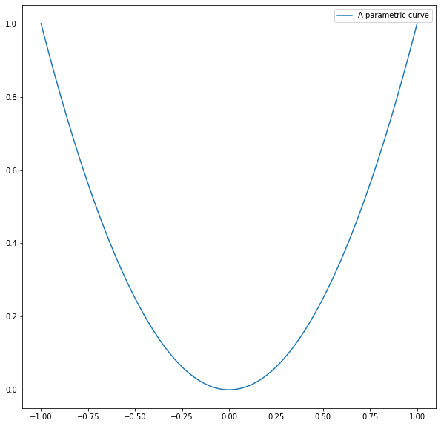Oppgave 3b

import numpy as np

import matplotlib.pyplot as plt

def f(x, y):

return (x**3 - 3*x*y**2) # Monkeysaddle function

# U = [-1,1] X [-1,1]

x = np.linspace(-1, 1, 40)

y = np.linspace(-1, 1, 40)

x, y = np.meshgrid(x, y)

X = x

Y = y

Z = f(x, y)

fig = plt.figure(figsize = (10, 10))

ax = plt.axes(projection = '3d')

ax.plot_surface(X, Y, Z, cmap = 'plasma', \

edgecolor = 'none')

plt.show()

